AP Calc AB Name: _______________

______________ _____________

WS Assessment

Target 2:

determining limits

**I can:**

* Determine the limits of functions using limit theorems
* Determine the limits of functions using equivalent expressions for the function or the squeeze theorem.

Unit 1: Limits and Continuity

HW Target 2

Unit 1 Progress Check MCQ Part B

Limits by algebraic simplification: The substitution rule cannot be used to evaluate $\lim_{x→c}f(x)$ if c is not in the domain of the function f (for instance, if it produces a zero in the denominator).

 

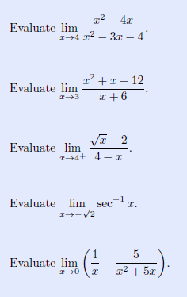

For the following, find and write the limit of the functions, then use graphing calculator to confirm it.

f(x) = $\frac{(x^{2}-6x+13)(x-2)}{ (x-2)}$, x → 2 g(x) = $\frac{(x^{3}-{8x}^{2}+25x-26)}{(x-2)}$, x → 2

h(x) = $\frac{(x^{3}-{3x}^{2}-4x-30)}{(x-5)}$, x → 5 k(x) = $\frac{(x^{3}-1)}{(x-1)}$, x → 1

Find the following limits. Hint divide

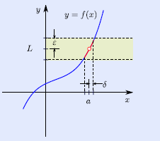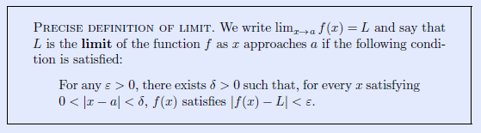



Find the following limits.

$\lim_{x→-∞}\frac{5x+sin(x)}{x}$ $\lim_{x→-∞}\frac{xsinx+2sinx}{{2x}^{2}}$

$\lim_{x→-∞}\left(\frac{2}{x}+1\right)\left(\frac{{5x}^{2}-1}{x^{2}}\right)$ $\lim_{x→-∞}\left(2-\frac{x}{x+1}\right)\left(\frac{x^{2}}{5+x^{2}}\right)$

$\lim_{x→-∞}\frac{ln(x^{2})}{ln(x)}$ $\lim_{x→-∞}\frac{ln(x+1)}{ln(x)}$ $\lim_{x→-∞}\frac{ln(x)}{log(x)}$

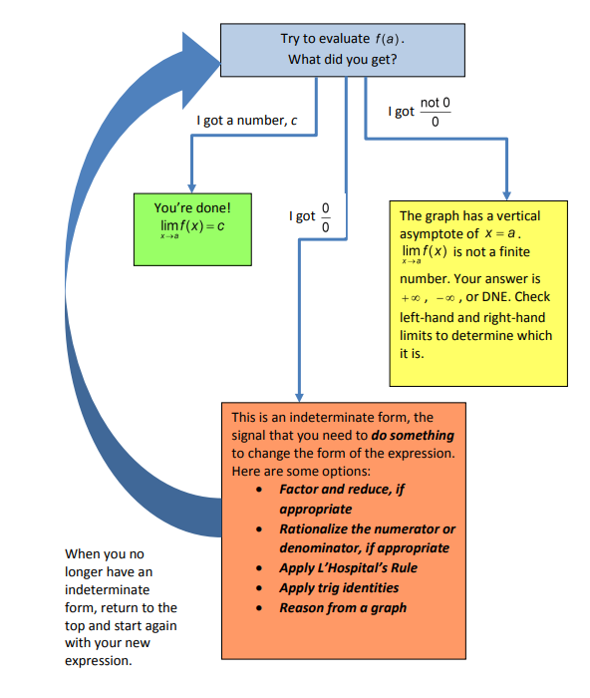Limit strategy flow chart

**The Squeeze Theorem (Sandwich)**

If g(x) ≤ f(x) ≤ h(x) for all x ≠ c in some interval about c and

$\lim_{x→c}g(x)=\lim_{x→c}h(x)=L$ then

$$\lim_{x→c}f(x)=L$$

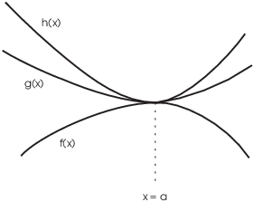

Use

Given g(x) = sin(π/2(x+2))+3 and h(x) = −14x3−3/2x2−9/4x+3 If function f(x) that satisfies

 g(x) ≤ f(x) ≤ h(x) for −2< x < 0 . Find $\lim_{x→-1}f(x)$. Graph to show

Given g(x) = -x2 – 2x +3 and h(x) = ½x2  + x + 13/2 If function f(x) that satisfies

 g(x) ≤ f(x) ≤ h(x) for −2< x < 0 . Find $\lim_{x→-1}f(x)$. Graph to stamp

Use Squeeze theorem to find $\underset{x→0}{lim⁡}\frac{sinx}{x}$ Hint g(x) = cos(x) and h(x) = 1 as the sandwich

Find $\lim_{x→0}x^{2}sin\left(\frac{1}{x}\right)$ Graph to illustrate and stamp. Hint -x2 < x2 sin(1/x) < x2

Use squeeze theorem to show that

Graph

Assessment

Show work



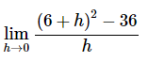



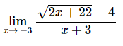





Graph